Bounded Propagation Without Ignition
Structural Limits of Local Coupling in Governance Network Simulations

Version 6 | Final
System of Eternity — Simulation Research Series

Abstract

We investigate disturbance propagation in locally coupled governance network simulations across four topologies:
chain, star, random-sparse, and fully connected. The full simulator evolves trust, disturbance, stability, and
cognitive distortion with local coupling, interventions, and stochastic updates; the main analysis uses a reduced
disturbance-centered interpretation for clarity. Propagation is classified with a strict conjunction rule:
affected share ≥ 20% of non-seed nodes, cascade depth ≥ 5, and sustained failure ≥ 3 consecutive steps.
Baseline and weak-coupling families often show high propagation, while targeted damping, gating, nonlinear
propagation, feedback, and hysteresis produce suppression regimes. Fine-grained scans over intrinsic decay reveal
topology-dependent threshold windows rather than a single universal flip point. Within the tested model family
and parameter ranges, we do not observe a robust sustained ignition phase as a stable attractor.

1. Introduction

Local interaction rules can produce rich cascades, but whether they are sufficient for sustained global ignition remains unresolved in decentralized governance-like systems. Prior work on contagion dynamics, percolation theory, and SIS/SIR-class models establishes that threshold-based spreading can exhibit sharp phase transitions under specific structural conditions. This study evaluates empirically whether those conditions are achievable under purely local coupling in the implemented simulator family.

Research Questions
• Can local coupling alone produce robust sustained ignition under tested conditions?
• How does topology shift propagation extent and threshold location?
• How do local extensions (targeted decay, gating, nonlinearity, feedback, hysteresis) reshape regime boundaries?

All conclusions are scoped to tested configurations. Full implementation details are available in the provided simulation scripts.

2. Model and Scope

2.1 Implemented Evidence Pipeline
Primary evidence is generated by the following simulation scripts:
• governance_network_sim.py
• governance_network_chain_sweep.py
• governance_network_topology_compare.py

2.2 Topology Definitions
Topology | Description
chain | Nodes arranged linearly, interacting only with immediate neighbors
star | Central hub connected to all peripheral nodes
fully connected | Each node interacts with all others
random-sparse | Connected chain backbone plus additional random long-range edges (extra_edge_probability = 0.06, defined in soe_v3_topology.py)

Note: random-sparse is not a pure ER G(N,p) model. The chain backbone ensures connectivity and introduces structural asymmetry absent from standard random graph models. All networks are undirected and unweighted.

2.3 Full-State Simulator Variables
The full simulator tracks four continuous node state variables:
Variable | Definition
Tᵢ(t) | Trust
Dᵢ(t) | Disturbance
Sᵢ(t) | Stability
Cᵢ(t) | Cognitive distortion

Nodes also maintain intervention and delayed-decision dynamics. All state variables are defined on bounded intervals and evolve over discrete synchronous time steps.

2.4 Simplified Update Structure (Interpretation Layer)
For interpretability, the dynamics are summarized as a locally coupled update sequence:
• Local node dynamics produce provisional next state
• Neighbor coupling injects disturbance and cognitive influence
• Optional activation gating selects contributing neighbors
• Optional nonlinear amplification and feedback modify effective input
• Targeted intrinsic decay damps disturbance-related dimensions

Dᵢ(t+1) = F_D(localᵢ, neighborsᵢ, gatingᵢ, feedbackᵢ, decayᵢ)
Cᵢ(t+1) = F_C(localᵢ, neighborsᵢ, gatingᵢ, feedbackᵢ, decayᵢ)

Tᵢ(t+1) and Sᵢ(t+1) evolve through local governance and intervention terms and coupling-mediated effects. When γ = 1 and β = 0, the system reduces to a linear coupling baseline. This interpretation provides a compact map for observed propagation behavior and does not replace the full implementation.

2.5 Propagation and Ignition Definitions
Run-level propagation is classified by strict conjunction of all three conditions:
• Affected share ≥ 20% of non-seed nodes
• Cascade depth ≥ 5
• Sustained failure ≥ 3 consecutive time steps

Ignition is defined as a regime of sustained global activation — high activation fraction maintained over time — not transient spikes. Propagation and ignition represent distinct dynamical regimes; the presence of propagation does not imply the emergence of ignition.

3. Experimental Setup

3.1 Common Settings
Parameter | Value
N | 50 nodes
Steps | 200 discrete time steps
Seed node | Node 0
Initialization | Exogenous disturbance injection on seed at initialization
Topologies | All four
Initial states | Near baseline with small random perturbations (not exact zeros)

3.2 Parameters and Experiment Families
The study aggregates multiple experiment families with varying run counts (20, 50, 100). Representative families include:
• Baseline topology comparisons
• Weak-coupling and reduced-shock scans
• Coarse/fine/PC targeted-decay scans
• Left/right gated scans
• Feedback and hysteresis scans

Extensive simulation sweeps across multiple parameter families were conducted to ensure robustness of the observed behavior. Representative summary outputs are available in the project codebase.

3.3 Observables
Observable | Description
Propagation share | Fraction of runs classified as propagating
Average failure rate | Proportion of nodes entering persistent failure
Time to first propagated collapse | Earliest step at which a non-seed node fails
Cascade depth distribution | Maximum shortest-path distance from seed to affected nodes
Largest survival cluster | Largest connected component with activation state 0
Spatial distribution labels | Localized / hub-localized / core-weighted / network-wide

4. Results

4.1 Baseline and Weak-Coupling Behavior
Multiple baseline and weak-coupling families contain configurations with propagation share near or equal to 1.00. Local propagation is therefore easy to trigger across portions of the tested parameter space, confirming that the propagation classification rule is sensitive to meaningful dynamics.
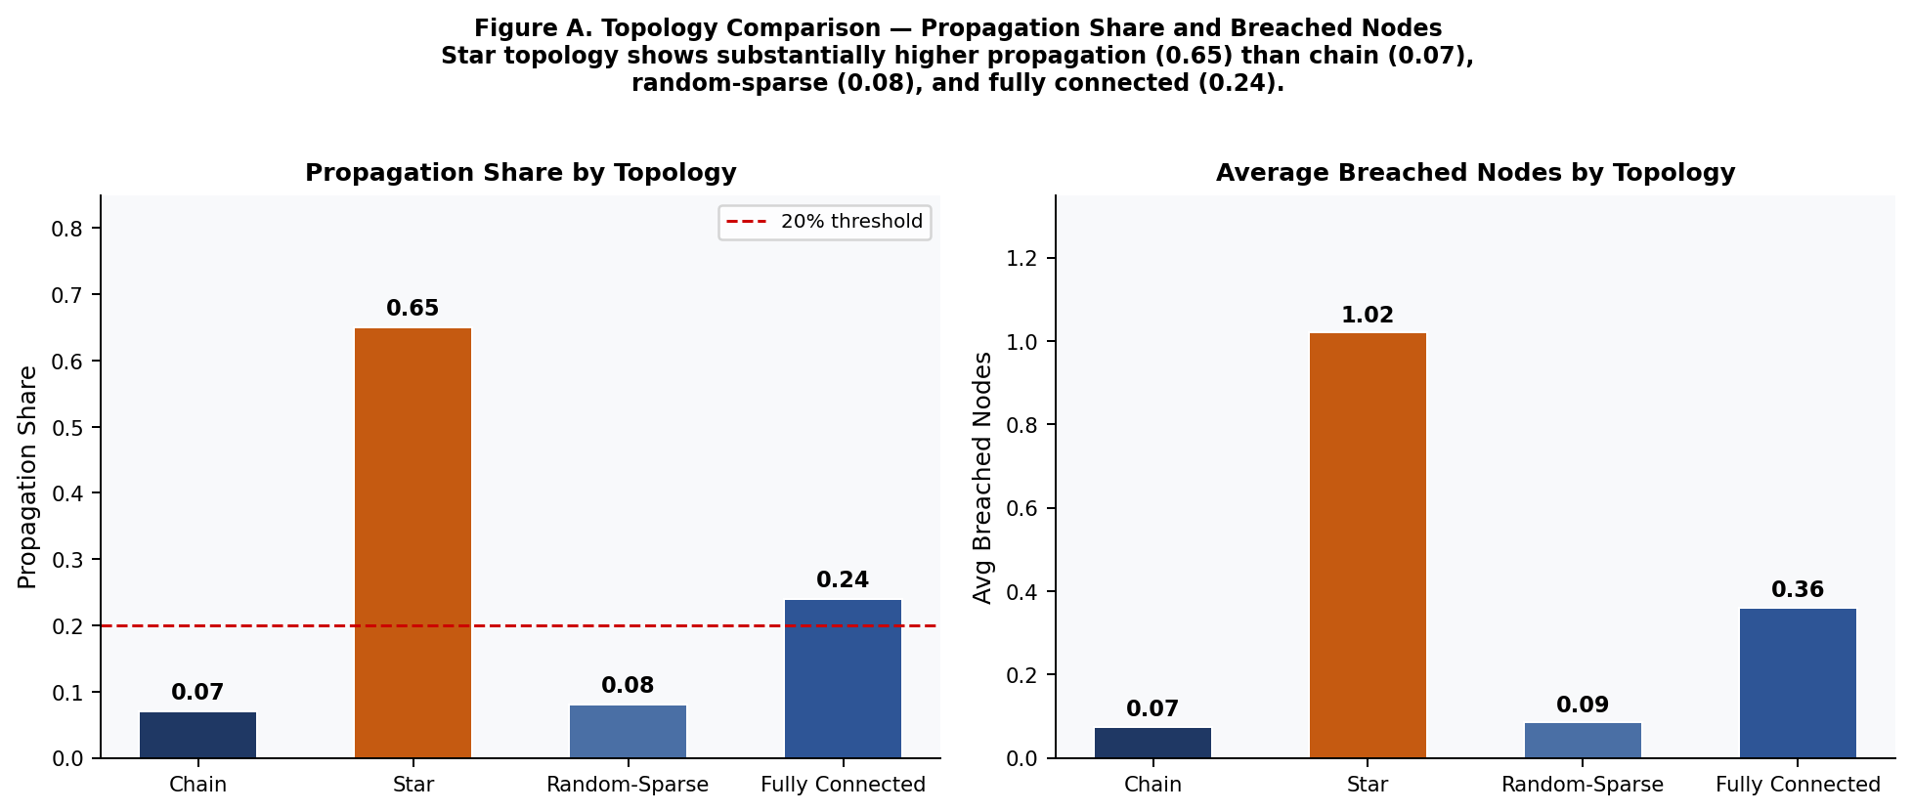
Figure A. Topology comparison — propagation share (left) and average breached nodes (right) across four topologies. Star topology produces substantially higher propagation (0.65) than chain (0.07), random-sparse (0.08), and fully connected (0.24), confirming topology-dependent threshold behavior.

4.2 Structural Importance of Targeted Decay
Applying decay indiscriminately across all state dimensions produces collapse-like artifacts inconsistent with meaningful threshold analysis. Restricting intrinsic decay to disturbance-related dimensions yields stable comparative regimes and enables interpretable threshold detection. This is a non-trivial structural finding: the decay targeting mechanism itself reshapes the regime boundary.

4.3 Fine Threshold Evidence (PC 100-Run Scan)
The 100-run targeted PC scan over alpha = 0.076..0.085 reveals:
k_C = 0.02 — Alpha Threshold Scan
Alpha range | 0.076 – 0.085
Propagation share | 0.39 → 0.01
Finding: Propagation share crosses threshold within the alpha range.

k_C = 0.03 — Alpha Threshold Scan
Alpha range | 0.076 – 0.085
Propagation share | 0.51 → 0.02
Finding: Threshold windows are topology-dependent, not universal. No single alpha value produces a simultaneous flip across all topologies.
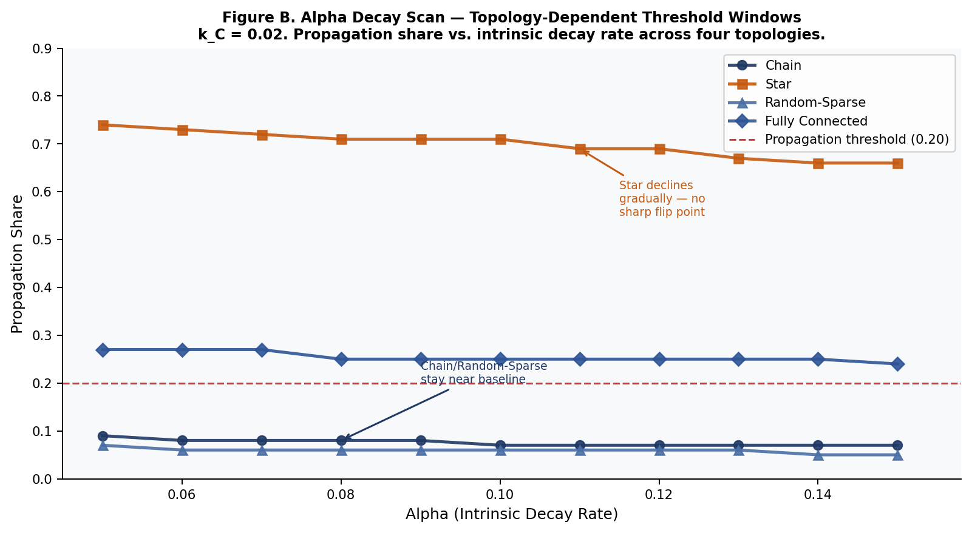
Figure B. Alpha decay scan (k_C = 0.02) — propagation share vs. intrinsic decay rate across four topologies. Star topology maintains high propagation across the full alpha range with gradual decline. Chain and random-sparse remain near baseline. No single alpha value produces a simultaneous flip across all topologies, confirming topology-dependent threshold windows.

4.4 Gated / Feedback / Hysteresis Suppression
Extended local mechanisms produce strong suppression in right-side parameter families:
Mechanism | Propagation Share
Right-gated scans | 0.00 – 0.03
Right feedback / hysteresis scans | 0.00 in reported grids

These results are consistent across repeated runs and multiple experimental families.

4.5 Interpretation
Across all tested configurations in this study, we do not identify a robust sustained ignition phase as a stable attractor.
Propagation can occur without robust sustained global ignition.
Within tested parameter ranges, propagation remains bounded or suppressible under targeted local mechanisms.

5. Discussion

5.1 Structural Implication
Local coupling can propagate disturbance, but the resulting regime is strongly controllable by damping and activation-control structure. This indicates that local coupling alone is insufficient to sustain self-reinforcing activation at the system level. The model is intentionally simplified to isolate structural effects of local coupling.

5.2 Topology Role
Topology modulates propagation extent, speed, and threshold location, but does not by itself force ignition in tested ranges. Topology acts as a quantitative modulator rather than a phase-determining mechanism: it influences how far and how fast disturbances travel, but not whether the system undergoes a qualitative transition to global activation.

5.3 Scope and Reproducibility Caveats
Conclusions are bounded by the following scope constraints:
• Finite parameter coverage across tested families
• Finite tested network sizes
• Fixed seed-node protocol in reported runs
• Current metric conventions in the pipeline

These are scope boundaries, not contradictions. The conclusions presented here are limited to the class of locally coupled models studied in this work and do not exclude the possibility of ignition under alternative structural assumptions.

5.4 Future Work
Priority extensions for future investigation:
• Broader size scaling experiments
• Seed-location sensitivity sweeps
• Explicit nonlocal/global feedback channels
• Alternative state accumulation and memory mechanisms

In particular, integrating global feedback or persistent accumulation mechanisms may enable ignition-like transitions, providing direct contrast to the bounded regimes observed here.

6. Conclusion

Within this simulator family and tested ranges, local coupling supports propagation but does not robustly
produce sustained ignition as a stable attractor. Threshold transitions exist and are topology-dependent,
while targeted damping and gating mechanisms can strongly suppress propagation.

The results indicate that additional structural ingredients beyond purely local coupling — such as global
feedback loops, energy accumulation processes, or state-dependent reinforcement extending beyond local
interactions — are likely required for robust ignition.

These findings identify a fundamental structural property of locally coupled governance-like systems and
provide a basis for understanding the structural conditions under which large-scale activation can or cannot emerge.

Data Availability

All simulation scripts and summary outputs used in this study are available through the project codebase and can be provided upon request.

